This document describes the understanding of JSON Web Token (JWT) with Spring Boot.
JWT, or JSON Web Token, is an open standard used to share security information between two parties — a client and a server. Each JWT contains encoded JSON objects, including a set of claims. JWTs are signed using a cryptographic algorithm to ensure that the claims cannot be altered after the token is issued.
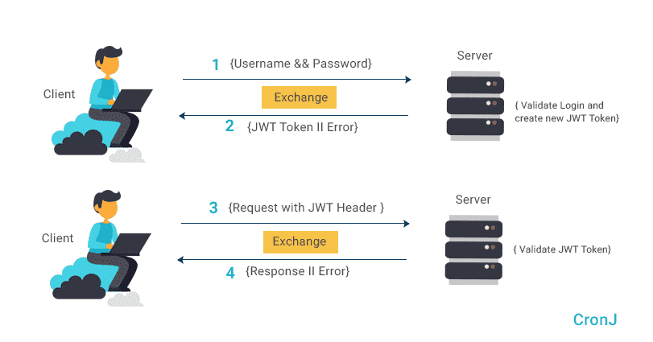

Official Link:
https://jwt.io/

Example 1:

Create a spring boot app using: https://start.spring.io/
Select Maven project, Java in language
Name: jwtSpringBootApp1
Group: springBootApp.examples
Package: springBootApp.examples.jwtSpringBootApp1
Artifact: jwtSpringBootApp1
Dependencies that need to add:
Spring Security, Spring Web

Files Structure:
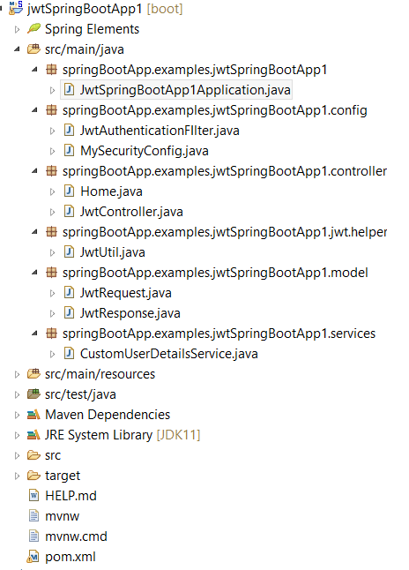
Pom.xml:
<dependencies>
<dependency>
<groupId>io.jsonwebtoken</groupId>
<artifactId>jjwt</artifactId>
<version>0.9.0</version>
</dependency>
<dependency>
<groupId>javax.xml.bind</groupId>
<artifactId>jaxb-api</artifactId>
<version>2.3.0</version>
</dependency>
<dependency>
<groupId>org.springframework.boot</groupId>
<artifactId>spring-boot-starter-security</artifactId>
</dependency>
<dependency>
<groupId>org.springframework.boot</groupId>
<artifactId>spring-boot-starter-web</artifactId>
</dependency>
<dependency>
<groupId>org.springframework.boot</groupId>
<artifactId>spring-boot-starter-test</artifactId>
<scope>test</scope>
</dependency>
<dependency>
<groupId>org.springframework.security</groupId>
<artifactId>spring-security-test</artifactId>
<scope>test</scope>
</dependency>
</dependencies>
CustomUserDetailsService.java class
package springBootApp.examples.jwtSpringBootApp1.services;
import java.util.ArrayList;
import org.springframework.security.core.userdetails.User;
import org.springframework.security.core.userdetails.UserDetails;
import org.springframework.security.core.userdetails.UserDetailsService;
import org.springframework.security.core.userdetails.UsernameNotFoundException;
import org.springframework.stereotype.Service;
@Service
public class CustomUserDetailsService implements UserDetailsService {
@Override
public UserDetails loadUserByUsername(String username) throws UsernameNotFoundException {
if (username.equals("root")) {
return new User("root", "root@123", new ArrayList<>());
} else {
throw new UsernameNotFoundException("User Not Found!");
}
}
}
JwtResponse.java class
package springBootApp.examples.jwtSpringBootApp1.model;
public class JwtResponse {
String token;
public JwtResponse(String token) {
this.token = token;
}
public JwtResponse() {
}
public String getToken() {
return token;
}
public void setToken(String token) {
this.token = token;
}
@Override
public String toString() {
return "JwtResponse [token=" + token + "]";
}
}
JwtRequest.java class
package springBootApp.examples.jwtSpringBootApp1.model;
public class JwtRequest {
String userName;
String password;
public JwtRequest() {
super();
}
public JwtRequest(String userName, String password) {
super();
this.userName = userName;
this.password = password;
}
public String getUserName() {
return userName;
}
public void setUserName(String userName) {
this.userName = userName;
}
public String getPassword() {
return password;
}
public void setPassword(String password) {
this.password = password;
}
@Override
public String toString() {
return "JwtRequest [userName=" + userName + ", password=" + password + "]";
}
}
JwtUtil.java class
For JwtUtil class:
https://github.com/koushikkothagal/spring-security-jwt/blob/master/src/main/java/io/javabrains/springsecurityjwt/util/JwtUtil.java

package springBootApp.examples.jwtSpringBootApp1.jwt.helper;
// methods-for generating token
// validate
// isExpire
// Util class for JWT
import java.util.Date;
import java.util.HashMap;
import java.util.Map;
import java.util.function.Function;
import org.springframework.security.core.userdetails.UserDetails;
import org.springframework.stereotype.Component;
import io.jsonwebtoken.Claims;
import io.jsonwebtoken.Jwts;
import io.jsonwebtoken.SignatureAlgorithm;
@Component
public class JwtUtil {

private String SECRET_KEY = "secret";

public String extractUsername(String token) {
return extractClaim(token, Claims::getSubject);
}
public Date extractExpiration(String token) {
return extractClaim(token, Claims::getExpiration);
}
public <T> T extractClaim(String token, Function<Claims, T> claimsResolver) {
final Claims claims = extractAllClaims(token);
return claimsResolver.apply(claims);
}
private Claims extractAllClaims(String token) {
return Jwts.parser().setSigningKey(SECRET_KEY).parseClaimsJws(token).getBody();
}
private Boolean isTokenExpired(String token) {
return extractExpiration(token).before(new Date());
}
public String generateToken(UserDetails userDetails) {
Map<String, Object> claims = new HashMap<>();
return createToken(claims, userDetails.getUsername());
}
private String createToken(Map<String, Object> claims, String subject) {
return Jwts.builder().setClaims(claims).setSubject(subject).setIssuedAt(new Date(System.currentTimeMillis()))
.setExpiration(new Date(System.currentTimeMillis() + 1000 * 60 * 60 * 10))
.signWith(SignatureAlgorithm.HS256, SECRET_KEY).compact();
}
public Boolean validateToken(String token, UserDetails userDetails) {
final String username = extractUsername(token);
return (username.equals(userDetails.getUsername()) && !isTokenExpired(token));
}
}
MySecurityConfig.java class
package springBootApp.examples.jwtSpringBootApp1.config;
import org.springframework.beans.factory.annotation.Autowired;
import org.springframework.context.annotation.Bean;
import org.springframework.context.annotation.Configuration;
import org.springframework.security.authentication.AuthenticationManager;
import org.springframework.security.config.annotation.authentication.builders.AuthenticationManagerBuilder;
import org.springframework.security.config.annotation.web.builders.HttpSecurity;
import org.springframework.security.config.annotation.web.configuration.EnableWebSecurity;
import org.springframework.security.config.annotation.web.configuration.WebSecurityConfigurerAdapter;
import org.springframework.security.config.http.SessionCreationPolicy;
import org.springframework.security.crypto.password.NoOpPasswordEncoder;
import org.springframework.security.crypto.password.PasswordEncoder;
import org.springframework.security.web.authentication.UsernamePasswordAuthenticationFilter;
import springBootApp.examples.jwtSpringBootApp1.services.CustomUserDetailsService;
@SuppressWarnings("deprecation")
@Configuration
@EnableWebSecurity
public class MySecurityConfig extends WebSecurityConfigurerAdapter {
@Autowired
private CustomUserDetailsService customUserDetailsService;
@Autowired
private JwtAuthenticationFIlter jwtFilter;
@Override
protected void configure(HttpSecurity http) throws Exception {
http.csrf().disable().cors().disable().authorizeRequests().antMatchers("/token").permitAll().anyRequest()
.authenticated().and().sessionManagement().sessionCreationPolicy(SessionCreationPolicy.STATELESS);
// Configure the filter
http.addFilterBefore(jwtFilter, UsernamePasswordAuthenticationFilter.class);
}
// Over
@Override
protected void configure(AuthenticationManagerBuilder auth) throws Exception {
auth.userDetailsService(customUserDetailsService);
}
@Bean
public PasswordEncoder passwordEncoder() {
return NoOpPasswordEncoder.getInstance();
}
@Bean
public AuthenticationManager authenticationManagerBean() throws Exception {
return super.authenticationManagerBean();
}
}
JwtAuthenticationFIlter.java
package springBootApp.examples.jwtSpringBootApp1.config;
import java.io.IOException;
import javax.servlet.FilterChain;
import javax.servlet.ServletException;
import javax.servlet.http.HttpServletRequest;
import javax.servlet.http.HttpServletResponse;
import org.springframework.beans.factory.annotation.Autowired;
import org.springframework.security.authentication.UsernamePasswordAuthenticationToken;
import org.springframework.security.core.context.SecurityContextHolder;
import org.springframework.security.core.userdetails.UserDetails;
import org.springframework.security.web.authentication.WebAuthenticationDetailsSource;
import org.springframework.stereotype.Component;
import org.springframework.web.filter.OncePerRequestFilter;
import springBootApp.examples.jwtSpringBootApp1.jwt.helper.JwtUtil;
import springBootApp.examples.jwtSpringBootApp1.services.CustomUserDetailsService;
// Check the user request with token
@Component
public class JwtAuthenticationFIlter extends OncePerRequestFilter {
@Autowired
private JwtUtil jwtUtil;
@Autowired
private CustomUserDetailsService customUserDetailsService;
@Override
protected void doFilterInternal(HttpServletRequest request, HttpServletResponse response, FilterChain filterChain)
throws ServletException, IOException {
// Get Jwt
// Start with Bearer
// Validate key
// The following line will get the header and get authorization value
String requestTokenHeader = request.getHeader("Authorization");
String username = null;
String jwtToken = null;
// Check null & format
if (requestTokenHeader != null && requestTokenHeader.startsWith("Bearer ")) {
jwtToken = requestTokenHeader.substring(7);
try {
username = this.jwtUtil.extractUsername(jwtToken);
} catch (Exception e) {
System.out.println(e);
}
UserDetails userDetails = this.customUserDetailsService.loadUserByUsername(username);
// Security
if (username != null && SecurityContextHolder.getContext().getAuthentication() == null) {
UsernamePasswordAuthenticationToken usernamePasswordAuthenticationToken = new UsernamePasswordAuthenticationToken(
userDetails, null, userDetails.getAuthorities());
usernamePasswordAuthenticationToken
.setDetails(new WebAuthenticationDetailsSource().buildDetails(request));
SecurityContextHolder.getContext().setAuthentication(usernamePasswordAuthenticationToken);
} else {
System.out.println("Token is not Validated");
}
}
filterChain.doFilter(request, response);
}
}
JwtController.java class
package springBootApp.examples.jwtSpringBootApp1.controller;

import org.springframework.beans.factory.annotation.Autowired;
import org.springframework.http.ResponseEntity;
import org.springframework.security.authentication.AuthenticationManager;
import org.springframework.security.authentication.BadCredentialsException;
import org.springframework.security.authentication.UsernamePasswordAuthenticationToken;
import org.springframework.security.core.userdetails.UserDetails;
import org.springframework.security.core.userdetails.UsernameNotFoundException;
import org.springframework.web.bind.annotation.RequestBody;
import org.springframework.web.bind.annotation.RequestMapping;
import org.springframework.web.bind.annotation.RequestMethod;
import org.springframework.web.bind.annotation.RestController;

import springBootApp.examples.jwtSpringBootApp1.jwt.helper.JwtUtil;
import springBootApp.examples.jwtSpringBootApp1.model.JwtRequest;
import springBootApp.examples.jwtSpringBootApp1.model.JwtResponse;
import springBootApp.examples.jwtSpringBootApp1.services.CustomUserDetailsService;

@RestController
public class JwtController {
@Autowired
private CustomUserDetailsService customUserDetailsService;
@Autowired
private JwtUtil jwtUtil;
@Autowired
private AuthenticationManager authenticationManager;

@RequestMapping(value = "/token", method = RequestMethod.POST)
public ResponseEntity<?> generateToken(@RequestBody JwtRequest jwtRequest) throws Exception {
System.out.println(jwtRequest);
try {
this.authenticationManager.authenticate(
new UsernamePasswordAuthenticationToken(jwtRequest.getUserName(), jwtRequest.getPassword()));
} catch (UsernameNotFoundException e) {
System.out.println(e);
throw new Exception("Bad Credentials: User not found");
} catch (BadCredentialsException e) {
System.out.println(e);
throw new Exception("Bad Credentials");
}
// Fine Area
// Generate Token Area
UserDetails userDetails = this.customUserDetailsService.loadUserByUsername(jwtRequest.getUserName());
String token = this.jwtUtil.generateToken(userDetails);
System.out.println("JWT " + token);
// Response Must be in Json such as - {"token" : "value"}
return ResponseEntity.ok(new JwtResponse(token));
}
}
Home.java
package springBootApp.examples.jwtSpringBootApp1.controller;
import org.springframework.web.bind.annotation.RequestMapping;
import org.springframework.web.bind.annotation.RestController;
@RestController
public class Home {
// Run the app with http://localhost:8080/welcome in postman, it will show: 401
// unauthorized

// type: UserName-user
// type: password-(security password-Display in console)

// http://localhost:8080/logout
@RequestMapping(value = "/welcome")
public String welcome() {
String text = "This is private page. ";
text += "This page is not allowed to unauthenticated users";
return text;
}
@RequestMapping(value = "/getUsers")
public String getUser() {
return "{\"name\":\"Root\"}";
}
}
JwtSpringBootApp1Application.java
package springBootApp.examples.jwtSpringBootApp1;
import org.springframework.boot.SpringApplication;
import org.springframework.boot.autoconfigure.SpringBootApplication;
@SpringBootApplication
public class JwtSpringBootApp1Application {
public static void main(String[] args) {
SpringApplication.run(JwtSpringBootApp1Application.class, args);
}
}
Execute the app.
Open the postman:
Before executing the following URL with the POST method:
http://localhost:8080/token
Enter the following JSON record in the body as a raw option (That values will match in CustomUserDetailsService.java):
{
"userName":"root",
"password":"root@123"
}
Now execute http://localhost:8080/token as a POST method.
It will generate the token. Copy the token value.
Open the new tab in postman; select the GET method & type:
http://localhost:8080/welcome
After executing the URL that will show HTTP status 403 forbidden because the URL is not authenticated.
Now, click on the Headers, write in key: Authorization and in value: Bearer token_value.
After providing token value the resultant value will display.

